STUDY II: DEVELOPMENT OF RISK MANAGEMENT PLAYBOOK (from NCDOT Project 2020-2274 Final Report by Jaselskis and Gholami, 2023)
Transportation projects involve numerous stakeholders, from contractors and engineers to government officials and the public. These projects are often complex, with many moving parts that can introduce significant risks to the project's success. Schedule delays and cost overruns can significantly impact the project and the community it serves [21] [22]. To enhance the chances of successful project delivery, one approach is to employ risk management strategies [7] [16] – [20]. The process of risk management entails the identification and analysis of potential risks, followed by the determination of suitable responses [5] [6]. This approach allows the project team to gain control over uncertainties and adopt a proactive stance rather than reacting to issues as they arise. Brainstorming, case-based approaches, and checklists are among the commonly employed tools and techniques for risk management, especially in the risk identification and response steps [7] [8].
Like many other large organizations, transportation agencies in the United States have recognized the significance of implementing effective risk management practices, which has led many agencies to adopt specific tools and techniques within their risk management programs [28]. The NCDOT is also actively seeking ways to enhance its risk management guidelines, especially as they pertain to risk mitigation strategies. This Study II of the NCDOT Risk Management Report addresses this goal by introducing a novel tool, the NCDOT Risk Management Playbook (see Appendix C). This tool is designed to give project managers and team members valuable risk insights, enabling them to identify and effectively mitigate potential risks associated with transportation projects.

Background
Risk mitigation is an integral component of comprehensive risk management practices, with a specific focus on minimizing the potential consequences associated with identified risks. Within the domain of transportation and infrastructure development, the implementation of effective risk mitigation strategies assumes paramount importance in ensuring project success and mitigating potential disruptions. This Study II centers around prevailing risk management practices, tools, and procedures employed within the NCDOT, with particular emphasis on the risk mitigation and response stage. The NCSU research team conducted a comparative analysis that encompasses standard practices employed by the DOTs of three other states, Washington (WSDOT), California (Caltrans), and Texas (TxDOT). The primary objective of this analysis is to identify potential opportunities to adopt successful risk mitigation practices within the NCDOT's existing risk management program.
The risk management guide published by the NCDOT concentrates on the preconstruction phase of project delivery in which risk management is deemed essential for all project and business units, regardless of project size and complexity. This guide therefore represents a best practice approach. The process of risk identification commences during the Project Initiation Stage (Stage 1) of the Project Delivery Network, immediately following the project's inclusion in the State Transportation Improvement Program (STIP). Subsequently, the project team collaborates with the project manager to select appropriate strategies after risks have been identified. The Risk Assessment Worksheet (RAW) undergoes regular updates throughout the project's various stages to ensure the incorporation of the most effective risk mitigation strategies as the project evolves [12].
In 2020, Jaselskis and Leca investigated the current state of the NCDOT's risk management program through interviews with NCDOT personnel. The findings of their study revealed that, although risk management practices are not formalized across all projects in all cases, risks are consistently considered as an inherent component of decision-making throughout all project phases. The interview respondents indicated that subject matter experts within the NCDOT, as well as external consultants in situations where the NCDOT lacks sufficient expertise, are responsible for identifying suitable mitigation strategies for the identified risks. The NCDOT also frequently convenes brainstorming sessions and conducts reviews of lessons learned and documentation from prior projects to inform decision-making processes for future endeavors [27].
Risk response strategies also hold significant importance within the risk management programs of other state DOTs such as WSDOT, Caltrans, and TxDOT [10] [11] [38]. These three innovative departments employ various tools, techniques, and formalized processes to ensure effective risk management, but the efficacy of their risk mitigation strategies is heavily reliant on the expertise and input provided by subject matter experts. A study by Baumann et al. in 2016 confirms and highlights the increased efficiency of risk management approaches that leverage the expertise of diverse groups of subject matter experts as opposed to relying solely on individual assessments [39]. The highest levels of risk management effectiveness are attained when appropriate response strategies are diligently executed in response to identified risks [10].
In sum, Study II explores the tools and procedures employed within the NCDOT and three other state DOTs in the context of risk response strategies. Across all the studied DOTs, the effectiveness of the risk response strategies hinges on the substantial input provided by subject matter experts. Therefore, the current lack of comprehensive tools for the development of in-house risk response and mitigation strategies serves as the primary impetus for conducting this study. The subsequent sections expound upon the study's objectives, provide an overview of the methodology employed, and present the results achieved.

Methodology
The objective of Study II is to create a tool that will aid NCDOT project teams in identifying and mitigating potential risks in transportation projects. The NCSU research team achieved this objective by developing the NCDOT Risk Management Playbook and validating it with input from subject matter experts at the NCDOT. The Playbook is made up of six spreadsheets, each focusing on a critical area of transportation projects: (1) Roadway, (2) Right-of-Way (ROW), (3) Structures, (4) Utilities, (5) Rail, and (6) Other. The Playbook outlines Primary Risks in these areas and suggests Key Questions that project managers should consider when assessing these risks, as well as potential Mitigation Strategies to avoid or minimize risks if they occur (see Appendix C).
The research team analyzed the NCDOT's past project claims and supplementary agreements to identify Primary Risks in the six critical areas. The team also conducted a comprehensive literature review to verify identified risks and potential mitigation strategies [40] [41]. During regular meetings, the research team presented the Playbook to NCDOT staff and project managers to refine and further validate the findings. After creating an initial draft, the research team sent the Playbook, along with a series of questions, to the NCDOT for feedback. The technical staff from various NCDOT Units, including Integrated Mobility, Photogrammetry, Signaling and Delineation, Hydraulics, and Environmental, provided feedback for the final version of the Playbook by answering specific questions. The questions put to NCDOT staff for final input on the Playbook are as follows.

- Which office or discipline best describes the area of your expertise?
- Do the Primary Risks listed in the Risk Management Playbook capture the most common or influential risks that you have experienced during a project?
- What are other risks you have faced on a typical project that should be captured in the Risk Management Playbook?
- Do the Key Questions help in determining the information that is needed to address the Primary Risks?
- Are there any additional questions you would ask yourself or your team when working on a typical project? (Please provide which Primary Risk such questions would pertain to.)
- Are the mitigation strategies listed in the Playbook the most effective ways to deal with these risks?
- Are there any additional strategies you would recommend for a typical project? (Please provide which Primary Risk such additional strategies would pertain to.)

3.3 Results
The NCDOT Risk Management Playbook comprises six spreadsheets in a table format that correspond to the six transportation project areas. Rather than displaying the tables, Figure 3.1 to Figure 3.7 presents each area's Primary Risk, Key Questions, and Mitigation Strategies. However, as these figures do not provide all the details, see Appendix C which presents the complete Playbook.

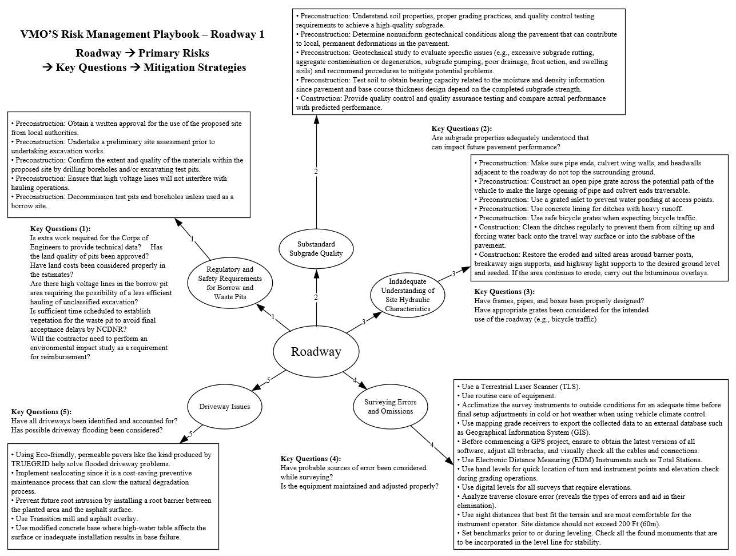
Figure 3.1: NCDOT Risk Management Playbook – Roadway (Part A).
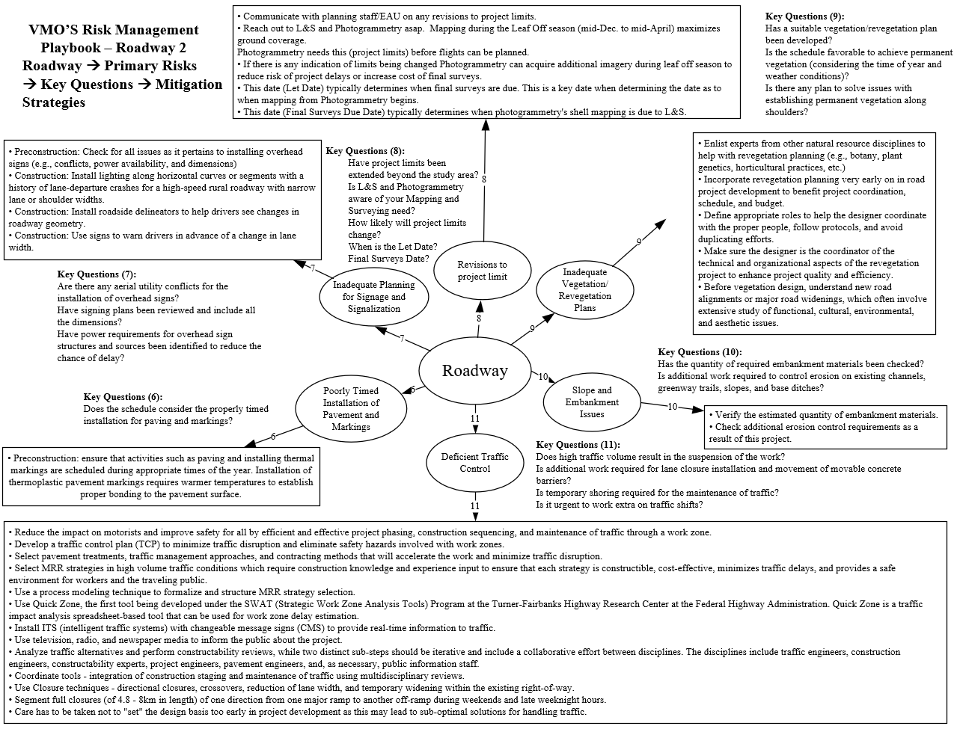
Figure 3.2: NCDOT Risk Management Playbook – Roadway (Part B).
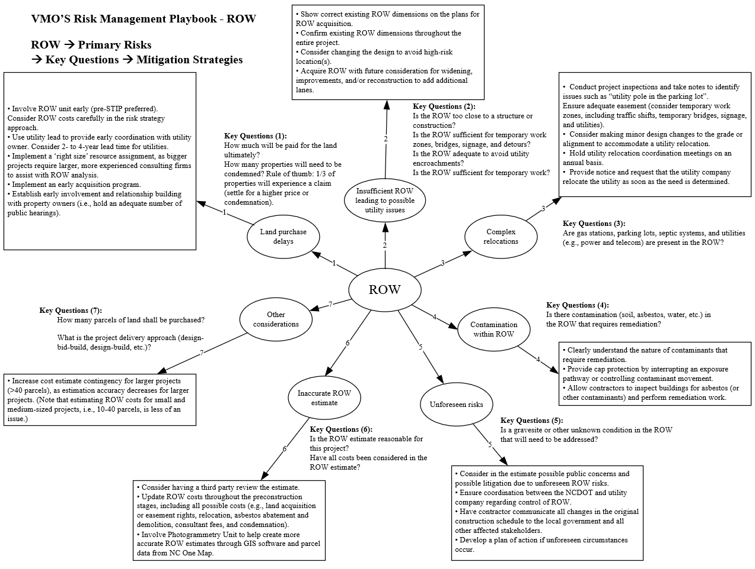
Figure 3.3: NCDOT Risk Management Playbook – Right of Way.
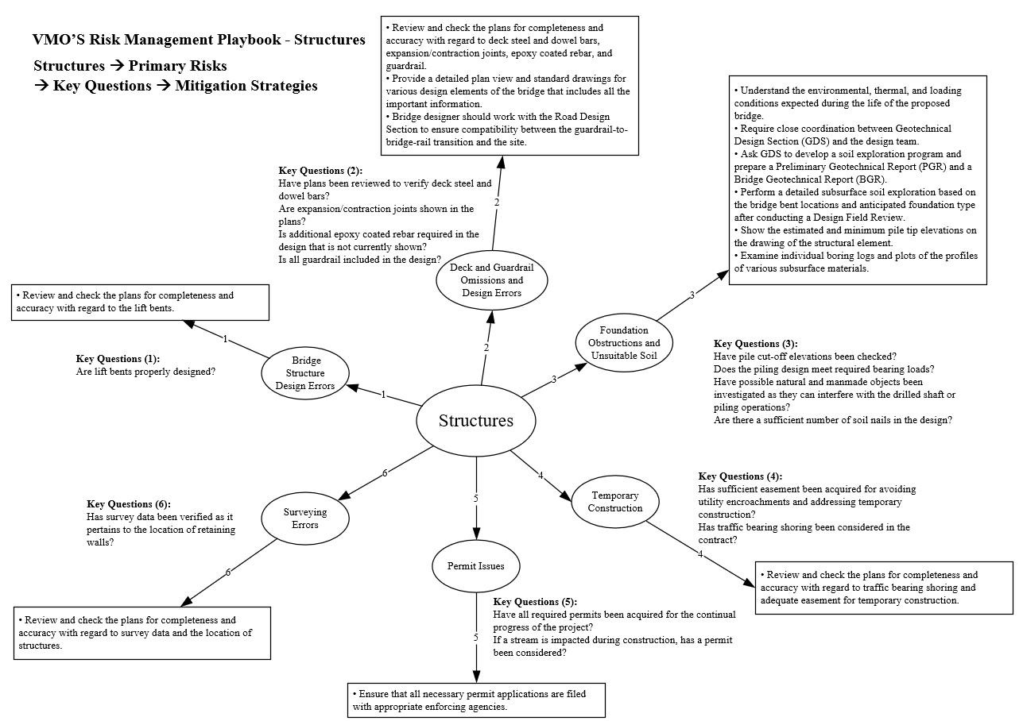
Figure 3.4: NCDOT Risk Management Playbook – Structures.
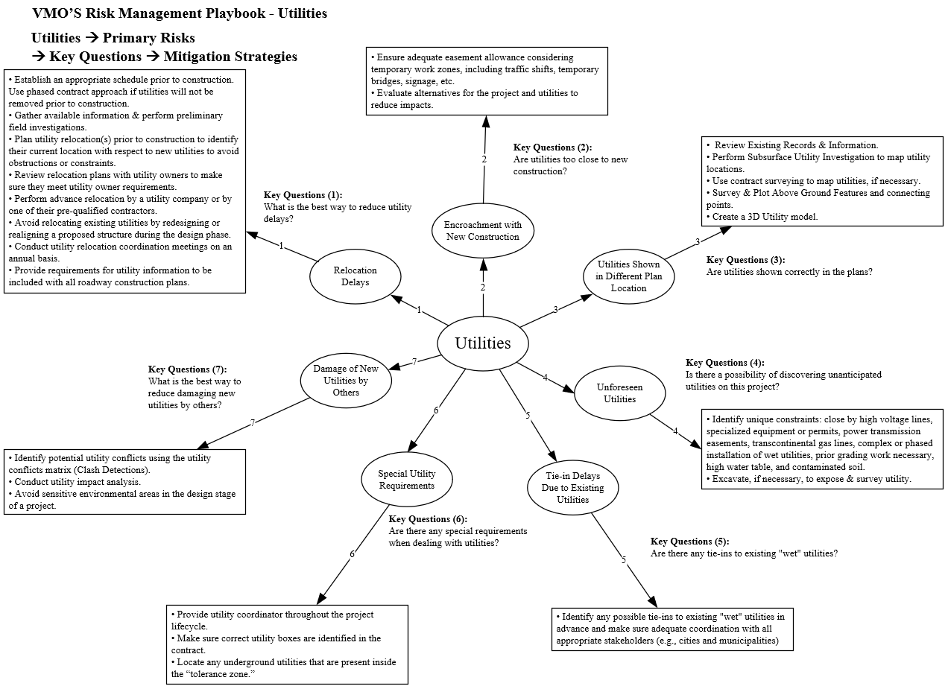
Figure 3.5: NCDOT Risk Management Playbook – Utilities.
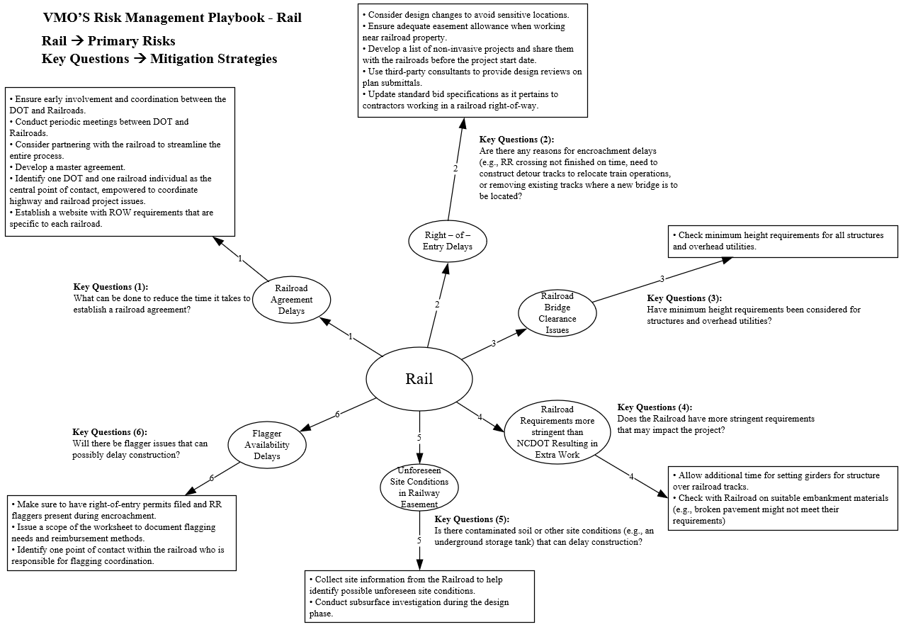
Figure 3.6: NCDOT Risk Management Playbook – Rail.
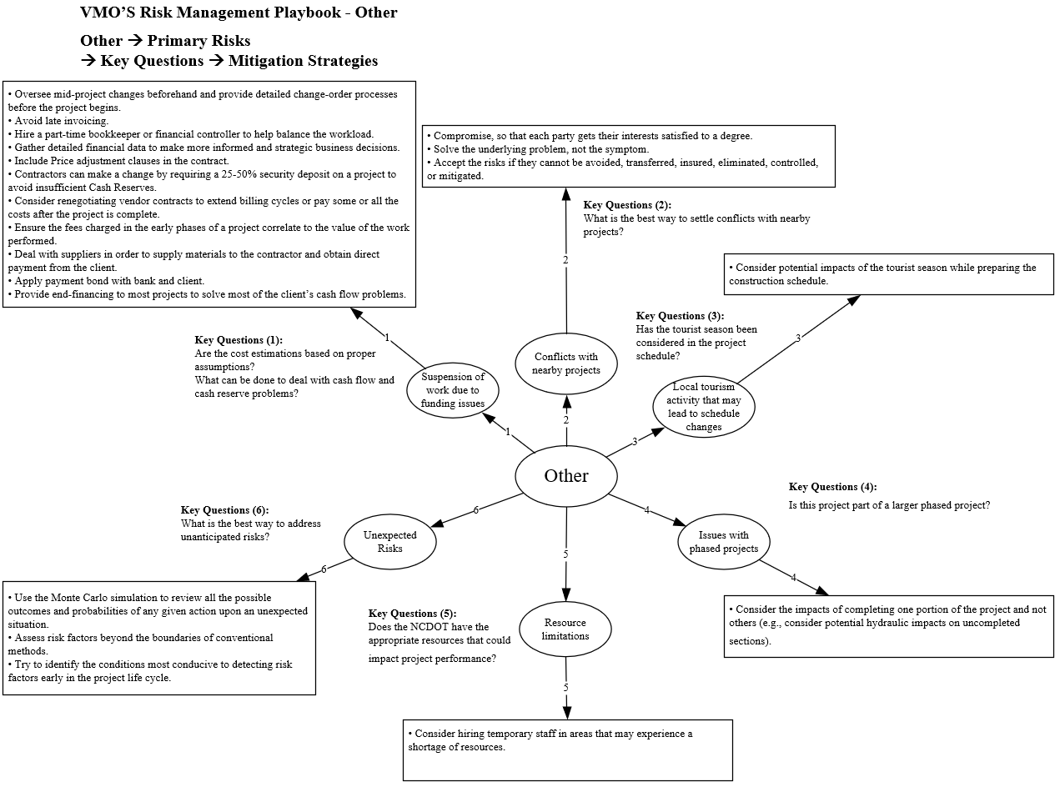
Figure 3.7: NCDOT Risk Management Playbook – Other.

Appendix C: North Carolina Department of Transportation Risk Management Playbook
Appendix C describes the components of the NCDOT Risk Management Playbook and includes the Primary Risks, with Key Questions and Mitigation Strategies, for each of the six critical areas: Roadway, Right-of-Way, Structures, Utilities, Rail, and Other.

NCDOT Playbook – Roadway
Primary Risk: Regulatory and safety requirements for borrow and waste pits

Key Questions:
- Is extra work required for the Corps of Engineers to provide technical data?
- Has the NC Department of Environmental Quality approved the land quality of the pits?
- Have land costs been considered properly in the estimates?
- Are high voltage lines present in the borrow pit area, which could lead to the possibility of less efficient hauling of unclassified excavation materials?
- Has sufficient time been scheduled for the establishment of vegetation for the waste pit to avoid final acceptance delays by the NC Department of Natural Resources?
- Will the contractor need to perform an environmental impact study as a prerequisite for reimbursement?
Mitigation Strategies:
- Obtain written approval from local authorities for use of the proposed site.
- Undertake a preliminary site assessment before excavation work.
- Confirm the extent and quality of the materials within the proposed site by drilling boreholes and/or excavating test pits.
- Ensure that high voltage lines will not interfere with hauling operations.
- Decommission test pits and boreholes unless they are used as borrow sites.

Primary Risk: Substandard subgrade quality

Key Questions:
- Are subgrade properties that could impact future pavement performance adequately understood?
Mitigation Strategies:
- Understand the soil properties, proper grading practices, and quality control testing requirements to achieve a high-quality subgrade.
- Determine the non-uniform geotechnical conditions throughout the pavement that could contribute to local permanent deformation.
- Conduct a geotechnical study to evaluate specific problems (e.g., excessive subgrade rutting, aggregate contamination or degeneration, subgrade pumping, poor drainage, frost action, and/or swelling soil) and recommend procedures to mitigate potential problems.
- Test the soil to determine the bearing capacity that relates to moisture and density information, as the pavement and designed base course thickness depend on the resultant subgrade strength.
- Perform quality control and quality assurance testing and compare actual performance with predicted performance.

Understand the soil properties, proper grading practices, and quality control testing requirements to achieve a high-quality subgrade.
Determine the non-uniform geotechnical conditions throughout the pavement that could contribute to local permanent deformation.
Conduct a geotechnical study to evaluate specific problems (e.g., excessive subgrade rutting, aggregate contamination or degeneration, subgrade pumping, poor drainage, frost action, and/or swelling soil) and recommend procedures to mitigate potential problems.
Test the soil to determine the bearing capacity that relates to moisture and density information, as the pavement and designed base course thickness depend on the resultant subgrade strength.
Perform quality control and quality assurance testing and compare actual performance with predicted performance.

Primary Risk: Inadequate understanding of site hydraulic characteristics

Key Questions:
- Have frames, pipes, and boxes been designed properly?
- Have appropriate grates been considered for the intended use of the roadway (e.g., bicycle traffic)?
Mitigation Strategies:
- Ensure that pipe ends, culvert wing walls, and headwalls adjacent to the roadway do not extend past the surrounding ground.
- Install a grated inlet to prevent water ponding at access points.
- Install flexible lining for ditches with heavy runoff.
- Install safe bicycle grates when expecting bicycle traffic.
- Clean the ditches regularly to prevent silting and forcing water back onto the roadway surface or into the sub-base of the pavement.
- Restore eroded and silted areas around barrier posts, breakaway sign supports, and highway light supports to the desired ground level, and seed those areas. If the area continues to erode, install bituminous overlays.

Primary Risk: Surveying errors and omissions

Key Questions:
- Have probable sources of surveying errors been considered?
- Has the survey equipment been maintained and calibrated properly?

Mitigation Strategies:
- Use a terrestrial laser scanner (TLS) to create 3D site models.
- Maintain routine care of equipment.
- Acclimatize the survey instruments to outside conditions before final setup in cold or hot weather when using vehicle climate control.
- Use mapping grade receivers to export collected data to an external database, such as a geographical information system (GIS).
- Before commencing a GPS project, obtain the latest versions of all software, adjust all tribraches, and visually check all cables and connections.
- Employ electronic distance measuring instruments, such as total stations.
- Use hand levels for the quick location of turn and instrument points and conduct elevation checks during grading operations.
- Use digital levels for all surveys that require elevations.
- Analyze traverse closure errors to identify and mitigate specific types of errors..
- Use sight distances that best fit the terrain and are most comfortable for the instrument operator. Sight distances should not exceed 200 ft (60 m).
- Set benchmarks before or during leveling. Check for all found monuments that are to be incorporated in the level line for stability.

Primary Risk: Driveway issues

Key Questions:
- Have all driveways been identified and considered for roadway construction?
- Has the possibility of driveway flooding been considered? From a roadside ditch? From a nearby stream?
Mitigation Strategies:
- Using eco-friendly permeable pavers, such as TRUEGRID© pavers, to help solve flooded driveway problems.
- Implement sealcoating, a cost-saving preventive maintenance process that can slow the natural degradation process.
- Prevent future root intrusion by installing a root barrier between the planted area and the asphalt surface.
- Install a transition mill and asphalt overlay.
- Install a modified concrete base where a high-water table affects the surface or inadequate installation results in base failure.

Primary Risk: Poorly timed installation of pavement and markings

Key Questions:
- Does the schedule accommodate the properly timed installation of pavement and markings?

Mitigation Strategies:
- Ensure that activities such as the paving and installation of thermal markings are scheduled during appropriate times of the year. For example, the installation of thermoplastic pavement markings requires warm temperatures to establish proper bonding to the pavement surface.

Primary Risk: Inadequate planning for signage and signalization

Key Questions:
- Are there any aerial utility conflicts that could affect the installation of overhead signs?
- Have signage plans been reviewed and do they include all necessary dimensions?
- Have power requirements for overhead sign structures and sources been identified to reduce the chance of delay?
- Has sufficient ROW been acquired for the installation of signs?
Mitigation Strategies:
- Check for all issues that pertain to the installation of overhead signs (e.g., utility conflicts, power availability, and dimensions).
- Install lighting along horizontal curves or segments of high-speed rural roadways that have narrow lanes and/or shoulders and a history of lane departure crashes.
- Install roadside delineators to help drivers see changes in the roadway geometry.
- Install signs to warn drivers of an upcoming change in lane width.

Primary Risk: Slope and embankment issues

Key Questions:
- Has the quantity of required embankment materials been checked?
- Is additional work required to control the erosion of existing channels, greenway trails, slopes, and base ditches?
Mitigation Strategies:
- Verify the estimated quantity of embankment materials.
- Check for additional erosion control requirements that may be needed for this project.

Primary Risk: Inadequate vegetation /revegetation plans

Key Questions:
- Has a suitable vegetation/revegetation plan been developed?
- Is the schedule favorable to achieve permanent vegetation (considering the time of year and weather conditions)?
- Does the establishment of permanent vegetation along the shoulders involve any potential problems?

Mitigation Strategies:
- Enlist experts from natural resource disciplines (e.g., botany, plant genetics, horticulture, etc.) to help with revegetation planning.
- Incorporate revegetation planning early in the road project development process to benefit project coordination, schedule, and budget.
- Define appropriate roles to help the designer coordinate work with appropriate personnel, follow protocols, and avoid duplicating efforts.
- Ensure that the designer is the coordinator of the technical and organizational aspects of the revegetation project to enhance project quality and efficiency.
- Before vegetation design, understand any new road alignments or major road widening , which often involves extensive study of functional, cultural, environmental, and aesthetic issues.

Primary Risk: Inadequate traffic control

Key Questions:
- Will high-volume traffic result in the suspension of work?
- Is additional work required for lane closures and movable concrete barriers?
- Is temporary shoring required for the control of traffic through the project site?

Mitigation Strategies:
- Reduce project impacts on motorists and improve safety by implementing efficient and effective project phasing, construction sequencing, and control of traffic through the work zone.
- Develop a traffic control plan to minimize traffic disruption and eliminate safety hazards typically associated with work zones.
- Select pavement treatments, traffic management approaches, and contracting methods that will accelerate the work and minimize traffic disruption.
- Select strategies for high-volume traffic conditions that require construction knowledge and experience input to ensure that each strategy is constructible and cost-effective, minimizes traffic delays, and provides a safe environment for workers and the traveling public.
- Use a process modeling technique to formalize and structure the maintenance repair and rehabilitation (MRR) strategy selection.
- Use Quick Zone, which is a traffic impact analysis spreadsheet-based tool that can be used for work zone delay estimation. Quick Zone is a tool being developed under the Strategic Work-Zone Analysis Tools (SWAT) program at the Federal Highway Administration’s Turner-Fairbanks Highway Research Center.
- Install intelligent traffic systems with changeable message signs to provide real-time traffic information for drivers.
- Segment full closures (4.8 km to 8 km in length) in one lane direction from one major ramp to another off-ramp during weekends and late weeknight hours.
- Use media to inform the public about the project.
- Analyze traffic alternatives and perform constructability reviews. These two distinct sub-steps should be iterative and include a collaborative effort among traffic engineers, construction engineers, constructability experts, project engineers, pavement engineers, and as necessary, public information staff.
- Coordinate tools and integrate construction staging and maintenance of traffic via multidisciplinary reviews.
- Use appropriate road closure techniques, including directional closures, crossovers, reduced lane width, and temporary widening within existing right-of-way.
- Do not set the design basis too early in the project development process to avoid suboptimal solutions for handling traffic.

Primary Risk: Revisions to project limits

Key Questions:
- Have project limits been extended beyond the study area?
- Are the Location and Surveys (L&S) and Photogrammetry Units aware of the project’s mapping and surveying needs?
- How likely is it that project limits will change?
- When is the let date?
- When is the final survey date?
Mitigation Strategies:
- Communicate with planning staff and the Environmental Analysis Unit regarding any revisions to project limits.
- Reach out to the L&S and Photogrammetry Units as soon as possible. Mapping during the leaf off-season (mid-December to mid-April) maximizes ground coverage.
- Provide project limits information to the Photogrammetry Unit in good time for the Photogrammetry Unit to plan flights.
- If limits are likely to be changed, then the Photogrammetry Unit can acquire additional imagery during the leaf off-season to reduce the risk of project delays or increase the cost of final surveys.
- Because the let date typically determines when final surveys are due, be aware that it is a key date when determining the date for the Photogrammetry Unit to begin mapping.
- Be aware that the date for the final surveys typically determines when shell mapping by the Photogrammetry Unit is due to the L&S Unit.

NCDOT Playbook – Right of Way
Primary Risk: Land purchase delays

Key Questions:
- How much will be paid for the land ultimately?
- How many properties will need to be condemned? Rule of thumb: 1/3 of properties will experience a claim (settle for a higher price or condemnation).
Mitigation Strategies:
- Involve the ROW Unit early (pre-STIP is preferred).
- Consider ROW costs carefully in the risk mitigation strategy approach.
- Use the utility lead to provide early coordination with the utility owner. Consider 2- to 4-year lead time for utilities.
- Implement a ‘right size’ resource assignment, as bigger projects require larger, more experienced consulting firms to assist with ROW analysis than smaller projects.
- Implement an early acquisition program.
- Establish early involvement and relationship building with property owner(s) (i.e., hold an adequate number of public hearings).

Primary Risk: Insufficient ROW leading to possible utility relocation delays, redesign to accommodate existing easement, and/or purchase of additional easement

Key Questions:
- Is the ROW too close to a structure or construction?
- Is the ROW sufficient for temporary work zones, bridges, signage, and detours?
- Is the ROW adequate to avoid utility encroachments?
- Is the ROW sufficient for temporary work?

Mitigation Strategies:
- Show correct existing ROW dimensions on the plans for ROW acquisition.
- Confirm existing ROW dimensions throughout the entire project.
- Consider changing the design to avoid high-risk locations.
- Acquire ROW with future consideration for widening, improvements, and/or reconstruction to add additional lanes.

Primary Risk: Complex relocations

Key Questions:
- Are gas stations, parking lots, septic systems, and utilities (e.g., power and telecom) present in the ROW?
Mitigation Strategies:
- Conduct project inspections and take notes to identify issues such as “utility pole in the parking lot”.
- Ensure adequate easement (consider temporary work zones, including traffic shifts, temporary bridges, signage, and utilities).
- Consider making minor design changes to the grade or alignment to accommodate a utility relocation.
- Hold utility relocation coordination meetings on an annual basis.
- Provide notice and request that the utility company relocate the utility as soon as the need is determined.

Primary Risk: Contamination within ROW

Key Questions:
- Is there contamination (soil, asbestos, water, etc.) in the ROW that requires remediation?
Mitigation Strategies:
- Clearly understand the nature of contaminants that require remediation.
- Provide cap protection by interrupting an exposure pathway or controlling contaminant movement.
- Allow contractors to inspect buildings for asbestos and/or other contaminants and perform remediation work.

Primary Risk: Unforeseen risks

Key Questions:
- Is there a gravesite or other unknown condition in the ROW that will need to be addressed?
Mitigation Strategies:
- Consider in the estimate possible public concerns and possible litigation due to unforeseen ROW risks.
- Ensure coordination between the NCDOT and the utility company regarding the control of ROW.
- Have the contractor communicate all changes in the original construction schedule to the local government and all other affected stakeholders.
- Develop a plan of action if unforeseen circumstances occur.

Primary Risk: Inaccurate ROW estimate

Key Questions:
- Is the ROW estimate reasonable for this project?
- Have all costs been considered in the ROW estimate?
Mitigation Strategies:
- Consider having a third party review the estimate.
- Update ROW costs throughout the preconstruction stages, including all possible costs (e.g., costs associated with land acquisition or easement rights, relocation, asbestos abatement and demolition, consultant fees, and condemnation).
- Involve the Photogrammetry Unit to help create more accurate ROW estimates through GIS software and parcel data from NC One Map.

Primary Risk: Other considerations

Key Questions:
- How many parcels of land shall be purchased?
- What is the project delivery approach (design-bid-build, design-build, etc.)?
Mitigation Strategies:
- Increase cost estimate contingency for larger projects (> 40 parcels), as estimation accuracy decreases for larger projects. (Note that estimating ROW costs for small and medium-sized projects, i.e., 10 to 40 parcels, is less of an issue.)

NCDOT Playbook – Structures
Primary Risk: Bridge structure design errors

Key Questions:
- Are lift bents properly designed?
Mitigation Strategies:
- Review and check the plans for completeness and accuracy about lift bents.

Primary Risk: Deck and guardrail omissions and design errors

Key Questions:
- Have plans been reviewed to verify deck steel and dowels?
- Are expansion/contraction joints shown on the plans?
- Is additional epoxy-coated rebar required in the design that is not shown in the plans?
- Are all guardrails included in the design?
Mitigation Strategies:
- Review and check the plans for completeness and accuracy about deck steel and dowels, expansion/contraction joints, epoxy-coated rebar, and guardrails.
- Provide a detailed plan view and standard drawings for the various design elements of the bridge that include all important information.
- Ensure that the bridge designer works with the Road Design Section to ensure compatibility between the guardrail-to-bridge-to-rail transition and the site.

Primary Risk: Foundation obstructions and/or unsuitable soil

Key Questions:
- Have pile cut-off elevations been checked?
- Does the pile design meet sufficient bearing load criteria?
- Have natural and manmade objects been investigated for their possible interference with drilled shafts or piling operations?
- Are soil nails sufficient in terms of number and type in the design?
Mitigation Strategies:
- Understand the environmental, thermal, and loading conditions that are expected during the life of the proposed bridge.
- Require close coordination between the Geotechnical Design Section (GDS) and the design team.
- Ask GDS personnel to develop a soil exploration program and prepare a preliminary geotechnical report and bridge geotechnical report.
- Perform a detailed subsurface soil investigation based on the bridge bent locations and anticipated foundation type after conducting a design field review.
- Ensure that the drawings show the estimated and minimum pile tip elevations of the structural elements.
- Examine individual boring logs and plots of the profiles of the various subsurface materials.

Primary Risk: Temporary construction omissions

Key Questions:
- Has sufficient easement been acquired to avoid utility encroachments and to address temporary construction?
- Has traffic-bearing shoring been considered in the contract?
Mitigation Strategies:
- Review and check the plans for completeness and accuracy about traffic-bearing shoring and adequate easement for temporary construction.

Primary Risk: Untimely or late permit acquisition

Key Questions:
- Have all required permits been acquired to ensure the continual progress of the project?
- Has a permit been considered for the possible impact of a stream during the construction phase?
Mitigation Strategies:
- Ensure that all necessary permit applications are filed with the appropriate enforcement agencies and that they are filed in good time.

Primary Risk: Surveying errors

Key Questions:
- Have survey data been verified as they pertain to the location of retaining walls?
Mitigation Strategies:
- Review and check the plans for completeness and accuracy about survey data and the location of structures.

NCDOT Playbook – Utilities

Primary Risk: Relocation delays

Key Questions:
- What is the best way to reduce utility delays?
Mitigation Strategies:
- Establish an appropriate schedule before construction. Use a phased contract approach if utilities will not be removed before construction.
- Gather available information and perform preliminary field investigations.
- Plan utility relocations before construction to identify their current location concerning new utilities to avoid obstructions or constraints.
- Review relocation plans with utility owners to ensure that the plans meet utility owner requirements.
- Relocate utilities in advance (by the utility company or one of its prequalified contractors).
- Avoid relocating existing utilities by redesigning or realigning a proposed structure during the design phase.
- Conduct utility relocation coordination meetings regularly. .
- Require that utility information is included with all roadway construction plans.

Primary Risk: Encroachment on new construction

Key Questions:
- Are utilities too close to new construction?
Mitigation Strategies:
- Ensure adequate easement to accommodate temporary work zones, including traffic shifts, temporary bridges, signage, etc.
- Evaluate alternatives for the project and utilities to reduce impacts.

Primary Risk: Utilities shown in different plan location

Key Questions:
- Are utilities shown correctly in the plans?
Mitigation Strategies:
- Review existing utilities records and information.
- Perform subsurface utility investigation to map utility locations.
- Conduct contract surveys to map utilities, if necessary.
- Survey and plot above-ground features and connecting points.
- Create a 3D utility model.

Primary Risk: Unforeseen utilities

Key Questions:
- Is the discovery of unanticipated utilities possible on this project?
Mitigation Strategies:
- Identify unique constraints, such as nearby high voltage lines, specialized equipment or permits, power transmission easements, transcontinental gas lines, complex or phased installation of wet utilities, prior grading work, high water table, and/or contaminated soil.
- Excavate, if necessary, to expose and survey utilities.

Primary Risk: Tie-in delays due to existing utilities

Key Questions:
- Are there any tie-ins to existing wet utilities?
Mitigation Strategies:
- Identify any possible tie-ins to existing wet utilities in advance and ensure adequate coordination with all appropriate stakeholders (e.g., owners and municipalities).

Primary Risk: Special utility requirements

Key Questions:
- Are there any special requirements when dealing with utilities?
Mitigation Strategies:
- Provide a utilities coordinator to be available throughout the project’s lifecycle.
- Ensure that correct utility boxes are identified in the plans.
- Locate any underground utilities that are inside the tolerance zone.

Primary Risk: Damage of new utilities by others

Key Questions:
- What is the best way to mitigate damage to new utilities made by others?
Mitigation Strategies:
- Identify potential utility conflicts using a utility conflicts matrix (Clash Detections).
- Conduct utility impact analysis.
- Avoid sensitive environmental areas in the design stage of the project.

NCDOT Playbook – Rail

Primary Risk: Railroad agreement delay

Key Questions:
- How can the time to establish a railroad agreement be reduced?
Mitigation Strategies:
- Ensure early involvement and coordination between the NCDOT and the railroad company.
- Conduct periodic meetings between the NCDOT and the railroad company.
- Consider partnering with the railroad company to streamline the entire process.
- Develop a master agreement.
- Identify one NCDOT representative and one railroad company representative as the central points of contact and empower those persons to coordinate highway and railway project issues.
- Establish a website with ROW requirements that are specific to each railroad company.

Primary Risk: Right-of-entry delay

Key Questions:
- What are the reasons for any encroachment delays (e.g., RR crossing not finished on time, the need to construct detour tracks to relocate train operations, or removing existing tracks where a new bridge is to be located)?
Mitigation Strategies:
- Consider design changes to avoid high-risk locations.
- Ensure adequate easement when working near railroad property.
- Use third-party consultants to provide a design review of plan submittals.
- Update standard bid specifications as they pertain to contractors working in a railway right-of-way..
- Determine the railroad company’s insurance requirements.

Primary Risk: Railroad bridge clearance issues

Key Questions:
- Have minimum height requirements been considered for structures and overhead utilities?
Mitigation Strategies:
- Check with the railroad company regarding suitable clearance requirements.

Primary Risk: The railroad company’s specific requirements are more stringent than those of the NCDOT, resulting in extra work

Key Questions:
- Does the railroad company have more stringent requirements than the NCDOT that may impact the project?
Mitigation Strategies:
- Allow additional time for setting girders for any structure over railroad tracks.
- Check with the railroad company regarding suitable embankment materials (e.g., broken pavement might not meet the railroad company’s requirements).

Primary Risk: Unforeseen site conditions within railway easement

Key Questions:
- Is there contaminated soil or other site conditions (e.g., an underground storage tank) that could delay construction?
Mitigation Strategies:
- Collect site information from the railroad company to help identify possible unforeseen site conditions.
- Conduct subsurface investigations during the design phase.

Primary Risk: Flagger availability delay

Key Questions:
- Will flagger issues possibly delay construction?
Mitigation Strategies:
- Make sure to have right-of-entry permits filed and railway flaggers present during encroachment.
- Issue a Scope of Work worksheet to document flagging needs and the reimbursement method.
- Identify one point of contact within the railroad company who is responsible for the coordination of flagging.

NCDOT Playbook – Other

Primary Risk: Suspension of work due to funding issues

Key Questions:
- Are the cost estimations based on proper assumptions?
- How should cash flow and cash reserve problems be addressed?

Mitigation Strategies:
- Avoid late invoicing.
- Hire a part-time bookkeeper or financial controller to help balance the workload.
- Gather detailed financial data to make informed and strategic business decisions.
- Include price adjustment clauses in the contract.
- Allow contractors to make a change by requiring a 25% to 50% security deposit to avoid insufficient cash reserves.
- Consider renegotiating vendor contracts to extend billing cycles or to pay some or all costs after the project is complete.
- Ensure that the fees charged in the early phases of the project correlate with the value of the work performed.
- Contract with suppliers directly to supply materials to the contractor and obtain direct payment from the client.
- Apply payment bond with bank and client.
- Provide end-financing to most projects to solve most of the client’s cash flow problems.

Primary Risk: Issues with phased projects

Key Questions:
- Is this project part of a larger phased project?
Mitigation Strategies:
- Consider the impacts of completing one portion of the project and not others (e.g., consider potential hydraulic impacts on uncompleted sections).

Primary Risk: Conflicts with nearby projects

Key Questions:
- What is the best way to settle conflicts with nearby projects?
Mitigation Strategies:
- Compromise so that each party’s interests are satisfied to a degree.
- Solve the underlying problem, not the symptom.
- Accept risks if they cannot be avoided, transferred, insured, eliminated, controlled, or mitigated.

Primary Risk: Local tourism activity that may lead to schedule changes

Key Questions:
- Has the tourist season been considered in the project schedule?
Mitigation Strategies:
- Consider the potential impacts of the tourist season when preparing the construction schedule.

Primary Risk: Resource limitations

Key Questions:
- Does the NCDOT have the appropriate resources that could impact project performance?
Mitigation Strategies:
- Consider hiring temporary staff in areas that may experience a shortage of resources.

Primary Risk: Unexpected risks

Key Questions:
- How are unexpected risks identified in a timely fashion?
Mitigation Strategies:
- Use Monte Carlo simulations to review all possible outcomes and probabilities of any given action in response to unexpected situations.
- Try to identify conditions that are most conducive to detecting risk factors early in the project’s lifecycle.

